Process & Decision Documentation

Project/Assignment Decisions

Side Quests and A4 (Individual Work)
Keep this section brief, typically 2 to 4 sentences.
Focus on:
- One significant decision or change I made was to make the obstacles have a border around it so that players cannot pass through and would instead bounce off.
  - I did this because originally in the code that was generated, players could directly pass through and it was more for serving decorative purposes, which I thought was kind of useless as we already had the moving background
- I also decided myself on the type of game and vibe that I wanted going for my and how I would implement the assignment prompt into it
Examples:
- Added bounce to obstacles
- Chose game colour palette myself
- Implemented fun easter eggs disguised as start constellations/symbols
- Made the camera moving (like ocean waves) even when player was not
You are not expected to document every alternative or iteration

Role-Based Process Evidence

Entry Header
Name: Katherine Chen
Role(s): Code editor and AI prompter
Primary responsibility for this work: Using AI to fulfill side quest 5’s requirements, as well as being the human decision point of how the level should progress.

Goal of Work Session
Briefly describe what you were trying to accomplish during this phase of the assignment.
Goal:
- Create a dreamscape like world that expands beyond just what user user’s current line of sight/camera can see
- Add little easter eggs in the form of dream like symbols that float across a dreamscape

Tools, Resources, or Inputs Used
- GenAI:
  - Claude Sonnett 4.6
  - VSCode Agent
- VSCode
- GitHub

GenAI Documentation

If GenAI was used (keep each response as brief as possible):
Date Used: Mon Feb 23 2026
Tool Disclosure: Claude Sonnett 4.5, VSCode Agent
Purpose of Use: Similar to the previous sidequests, after reading the assignment description I had an idea of the ideal game that I wanted it to be and mental image of what I wanted the game to look like, but did not know the specific commands to get VSCode’s AI to do exactly what I wanted to do. That’s why I first fed the code to Claude and explained my idea in depth, letting it create better and more accurate prompts for VSCode to interpret. This cuts down on a lot of back and forth unnecessary conversations.
Summary of Interaction: Claude code was in charge of generating the prompts that I would give to VSCode to implement directly into the code. I mainly had some back and forths with VSCode regarding minor fixes to the overall structure, as not all of claude’s prompts hit the mark of what I wanted.
Human Decision Point(s): As mentioned, there is only so much AI can do with code and a vision, I had to be on the judging end of whether or not I liked what AI generated with the prompts given. If not, then I would have back and forth conversations to alter or fix those areas. For example, claude started out by giving me an original prompt of having a hard blue background, resembling the night sky, but I felt it was a bit too heavy and out of place and lessens the impact of everything else, so I changed it to a pastel dreamlike purple.
Integrity & Verification Note: Since I personally know HTML, JavaScript, and CSS, I was able to personally verify most of which the code wrote and understood that it was mostly correct. Additionally, as mentioned, I combatted/fixed the areas that I wasn’t satisfied with by inputting my own prompts. Also, there were minor tweaks that I did directly to the code myself, as certain values (eg. The bounce when player interacts with an obstacle) were not up to par with my mental image.
Scope of GenAI Use: GenAI did not come up with the idea, I did that myself. Claude did, however, turn my idea into actionable prompts, to which VSCode then implemented directly onto the code itself.
Limitations or Misfires: There were certain parts in which the code misunderstood my intentions. For example, when I wanted a moving camera, I was looking more like a deep ocean, lucid dreaming vibe, but claude’s prompts + VSCode’s implementations made it look more like a nightmare earthquake.

Summary of Process (Human + Tool)
- I utilized AI to make my creative game vision into code
- I utilized it to troubleshoot some errors
- I came up with my own ideas on how the code should look (dreamscape lucid dreaming vibe, with calm subtle moving camera) in order to fulfill the sidequest requirements
- I did some of my own tweaking directly to the code when it was too tedious to ask AI (ect. Change how much “shake” the camera applied and the colour of the text on the top left as it was practically unreadable bad WCAG violations in earlier iterations)

Decision Points & Trade-offs
- The AI isn’t always going to give me what I want, for example, when one of the prompts that Claude gave me was to include camera “breathing” moments, however VSCode’s ai made it look like an earthquake instead, completely destroying and semblance of “dream” in the dreamscape. I then had to prompt VSCode to make it more “subtle” and natural, which was a decision that I came to after observing how the results didn’t line up with expectations.
- Also the colour scheme that the AI chose for some parts I wasn’t satisfied with so I made my own palette and manual tweaks
- Also, the moving background in earlier iterations was too harsh so I made it more of a gradient, “free” feel

Verification & Judgement
Explain how you evaluated whether your decision or change was appropriate:
- Playtesting on live server many times before publishing to github. Also playtested on github’s links to make sure everything was working as different platforms take into consideration different issues (uppercase variables, ect.)
- WCAG colour contrast comparisons
- Cross referencing with my own mental image

Limitations, Dead Ends, or Open Questions
- I think the main limitation is that AI cannot 100% implement the image I have in mind, no matter how well I explain it. It can come close, but as a designer, there are always things to nitpick on.
  - Eg. Background colour
- Currently I am thinking about what this would look like if there were levels added to it. Currently it’s more like open world exploration, but if there was actually a purpose to the game, that would be fun.

Appendix
Please include a full transcript of your conversation with the GenAI. GenAI transcripts are used for transparency and verification only and are not assessed for writing quality or completeness.
Note: If GenAI is used in another language, you must include both the original language and a translated transcript in the appendix
Prompt | Answer
Based off this [example 4 code files], and the following goal: “Create a reflective or meditative camera experience that scrolls through a world larger than the screen. Use pacing and motion to evoke emotion.”, craft me a series of prompts that will create a dreamscape/memory world sort of vibe. I want it to be pastely with a surrealistic feel, with fragmented floating platforms and hidden symbols that get revealed/reemembererd when touched | Dreamscape / Memory World 🌙  Great choice — this is a really evocative theme. Here's the vision before we get into prompts:  The concept: The player drifts through a fragmented dreamworld — pastel colours, soft floating geometry, a camera that "breathes" (gently pulses its zoom or sways). Hidden memory symbols are scattered across the world; when the player gets near one, it glows and fades like a half-remembered thought. The overall feeling should be quiet, slightly melancholic, and wonder-filled.  What We're Building  Before the prompts, here's a plain-English map of the changes across each file so you understand what you're asking the AI to do:  world.json — New world colours (pastels), more obstacles/symbols, a slower camera lerp, and new fields for "memory objects" with positions and icons.  WorldLevel.js — Draw the dreamy background (gradient-like layered rects, floating soft shapes), draw memory symbols that pulse/glow when the player is near, and update the HUD to feel minimal and poetic.  Player.js — Slower, floatier movement with inertia (the player glides to a stop rather than stopping instantly), giving that weightless dream feeling.  sketch.js — Add a subtle camera "breathe" (slow sine-wave sway offset), and a vignette overlay drawn on top of everything.  The Prompts — In Order  Do these one file at a time. Open the file in VS Code, highlight all the code, and paste the prompt into Copilot Chat.  1. Start with world.json  Prompt: "Rewrite this world.json for a dreamscape / memory world theme in a p5.js game. The world should be large (at least 2400x1600). Set the background colour to a deep soft purple (like [28, 18, 52]). Add a camera section with a slow lerp value around 0.07 and a breatheSpeed of 0.4 and breatheAmount of 3. Add a memories array with at least 8 objects, each with an x, y, symbol (choose from: "△", "◯", "✦", "☽", "∞", "◇"), and a label (a short poetic 3–5 word phrase like "the day you left" or "warm summer static"). Keep the existing obstacles array but replace the placeholder with 6–8 soft floating rectangular shapes scattered across the world."  2. Then WorldLevel.js  Prompt: "Rewrite this WorldLevel.js for a p5.js dreamscape / memory world. Keep the class structure and constructor reading from JSON. Make these changes: (1) drawBackground() should fill with the world's bg colour and draw 3 layers of soft translucent ellipses drifting across the background as ambient shapes — use frameCount with slow sine waves to gently shift their y position. (2) drawWorld() should draw obstacles as soft rounded rectangles with no stroke, in muted lavender/rose/mint pastel colours, cycling through a small palette array. (3) Add a drawMemories(player) method that loops through this.memories (loaded from JSON), draws each as a glowing pulsing symbol using a sine wave on frameCount for opacity, and if the player is within 80px, draws the label text fading in beneath it. (4) Update drawHUD to be minimal — just a small italic poetic line in the top left in a light colour, no coordinate debug info."  3. Then Player.js  Prompt: "Rewrite this Player.js for a dreamscape p5.js experience. Instead of instant movement, give the player inertia — use this.vx and this.vy velocity variables. Each frame, add input direction to velocity scaled by an acceleration of 0.4, then multiply velocity by a friction of 0.88 so the player glides to a stop. Cap speed at this.s. Draw the player as a soft glowing white ellipse (radius ~10) with a larger translucent halo ellipse behind it (radius ~22, low opacity). No stroke."  4. Finally sketch.js  Prompt: "Rewrite this sketch.js to work with the updated WorldLevel, Player, and world.json for a dreamscape experience. Keep the same setup structure. Add these features: (1) Camera breathe — each frame offset the camera by sin(frameCount * breatheSpeed) * breatheAmount in both x and y, where those values come from level.breatheSpeed and level.breatheAmount. (2) After drawing the world and player (inside the push/pop), call level.drawMemories(player). (3) After the pop, draw a vignette overlay: a dark radial gradient rect covering the full canvas using drawingContext and a canvas radial gradient from transparent centre to rgba(10,5,20,0.7) at the edges. (4) Keep the R key reset. Remove the HUD coordinate debug line since the new HUD is poetic."  Tips for Using Copilot  - Always paste the full existing file into Copilot Chat alongside the prompt — say "Here is my current file: [paste code]. Now apply this prompt to it."  - If the output breaks something, paste the error back and say "I got this error, fix it while keeping the dreamscape style."  - Do the files in the order above — world.json first because the other files depend on what fields exist in it.  - After all 4 files are done, ask Copilot: "In sketch.js, make sure drawMemories is being called with the right arguments and that level.breatheSpeed and level.breatheAmount are being read correctly from the WorldLevel constructor." — this is a good sanity-check pass.  Come back once you've got it running and I can help you debug, tweak the feeling, or add the bonus interactive discovery mechanic in more depth!
"Rewrite this world.json for a dreamscape / memory world theme in a p5.js game. The world should be large (at least 2400x1600). Set the background colour to a deep soft purple (like [28, 18, 52]). Add a camera section with a slow lerp value around 0.07 and a breatheSpeed of 0.4 and breatheAmount of 3. Add a memories array with at least 8 objects, each with an x, y, symbol (choose from: "△", "◯", "✦", "☽", "∞", "◇"), and a label (a short poetic 3–5 word phrase like "the day you left" or "warm summer static"). Keep the existing obstacles array but replace the placeholder with 6–8 soft floating rectangular shapes scattered across the world." | Now I'll rewrite the world.json file with the dreamscape/memory theme:  Edited  world.json+66-5  Done! I've rewritten your world.json with a dreamscape/memory theme featuring:  - World dimensions: 2400×1600 (maintained)  - Background: Deep soft purple [28, 18, 52]  - Camera: Slow lerp of 0.07 with breathing effect (speed 0.4, amount 3)  - Memories array: 8 objects scattered throughout the world with poetic labels ("the day you left", "warm summer static", "echoes of laughter", etc.) and symbolic characters (△, ◯, ✦, ☽, ∞, ◇)  - Obstacles: 8 soft floating rectangular shapes with varied dimensions and rounded corners, distributed across the world  The memories are positioned strategically across the world space to create a sense of exploration and discovery in this dreamlike environment.  Claude Haiku 4.5 • 1x  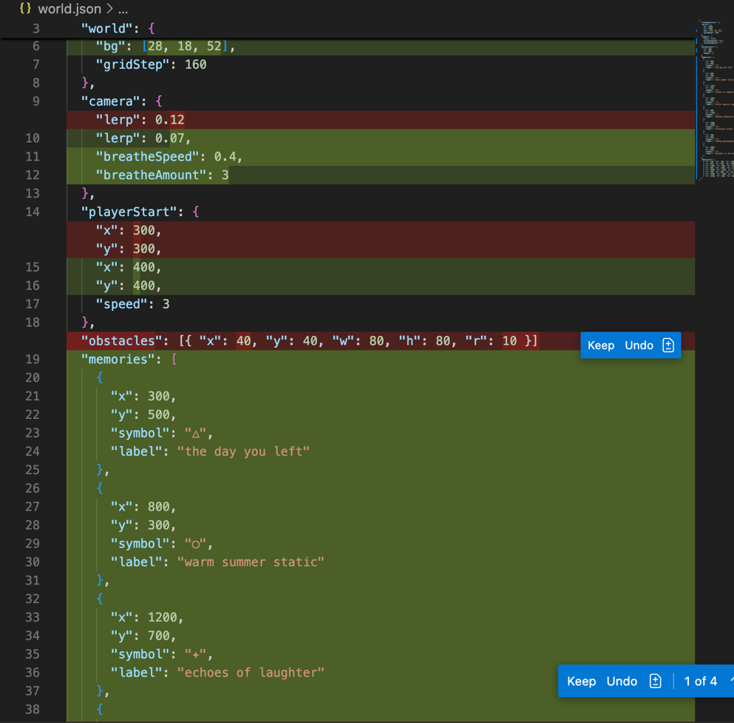
actually change the background colour to a more dreamy like purple | Changed the background to [120, 100, 160] — a softer, more ethereal purple that feels more dreamy and magical.
Rewrite this WorldLevel.js for a p5.js dreamscape / memory world. Keep the class structure and constructor reading from JSON. Make these changes: (1) drawBackground() should fill with the world's bg colour and draw 3 layers of soft translucent ellipses drifting across the background as ambient shapes — use frameCount with slow sine waves to gently shift their y position. (2) drawWorld() should draw obstacles as soft rounded rectangles with no stroke, in muted lavender/rose/mint pastel colours, cycling through a small palette array. (3) Add a drawMemories(player) method that loops through this.memories (loaded from JSON), draws each as a glowing pulsing symbol using a sine wave on frameCount for opacity, and if the player is within 80px, draws the label text fading in beneath it. (4) Update drawHUD to be minimal — just a small italic poetic line in the top left in a light colour, no coordinate debug info | Done! I've rewritten WorldLevel.js with a dreamy memory world aesthetic:  - drawBackground(): Fills with the world's bg color and renders 3 layers of soft translucent ellipses that drift vertically using sine waves at different speeds, creating a gentle ambient movement  - drawWorld(): Draws obstacles as soft rounded rectangles with no stroke, cycling through a muted pastel palette (rose, blue, mint, peach, lavender, sage)  - drawMemories(player): New method that loops through memories, draws glowing pulsing symbols using sine waves for opacity, and displays poetic labels when the player is within 80px with smooth fade-in  - drawHUD(): Minimal, just a small italic poetic line ("drifting through memories...") in light purple in the top left, no debug info  Make sure to call drawMemories(player) in your sketch.js draw loop after drawing the world!  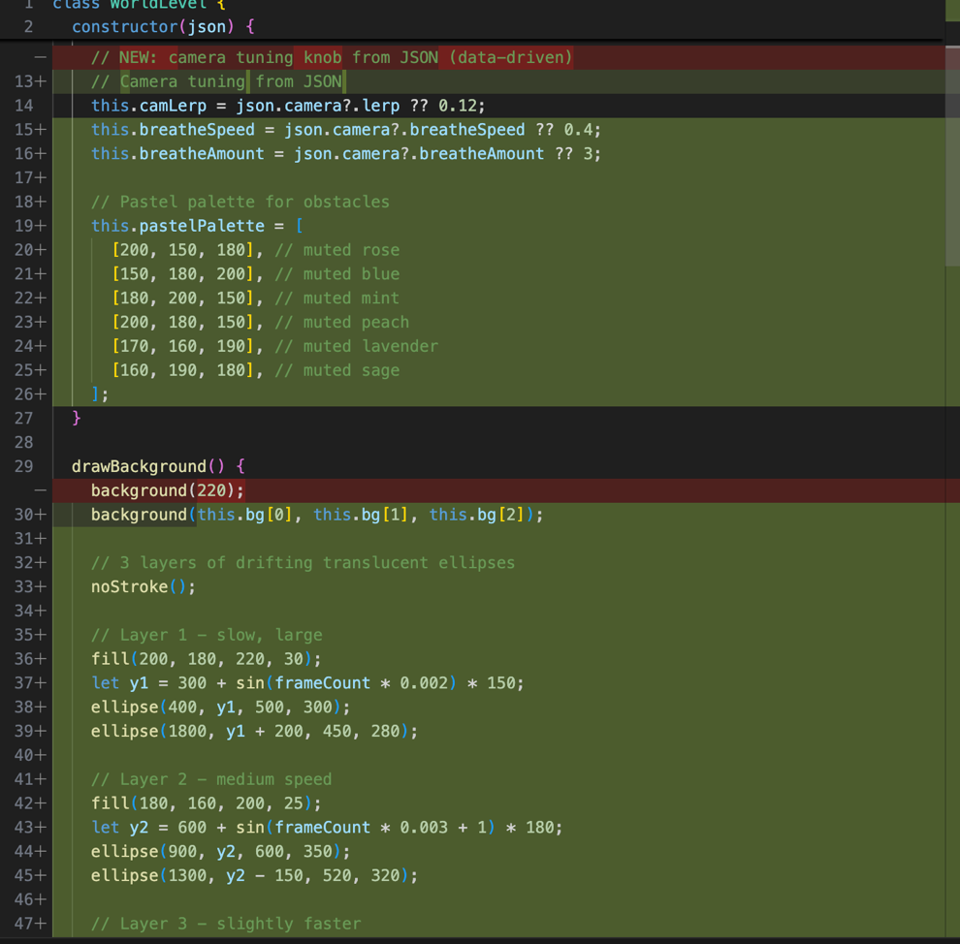
make the ellipses drifting across the background as ambient shapes more soft and it gould have more of a gradient look | 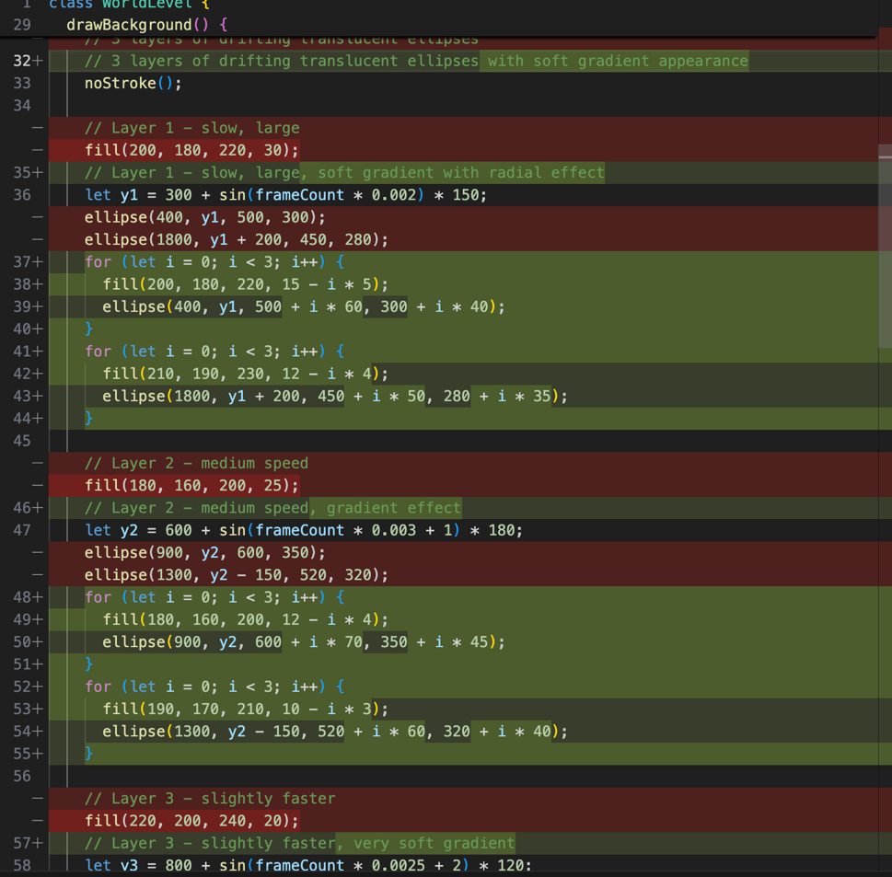
make it so thatthe deeper or more down I go, the darker the background is and the top or higher I go it looks lighter. just make it sort of like gradient variations building around the current bg colour | Done! The background now has a vertical gradient that gets lighter toward the top and darker toward the bottom, based on your base purple color. The gradient amount is ±50 RGB units from the center color, creating a subtle but noticeable shift as you explore the world.  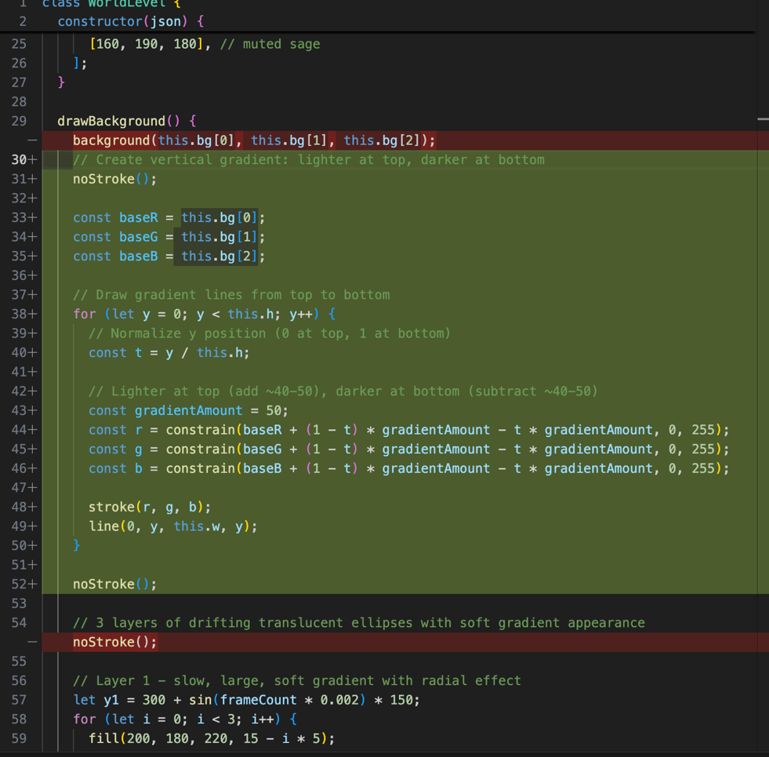
make it so that the obstables have a glowing white border around them, making it look more ethereal | Done! The obstacles now have a glowing white border that creates a soft, layered ethereal effect. The glow consists of multiple strokes with decreasing opacity, radiating outward from each rectangle to give them a dreamy, luminous appearance.  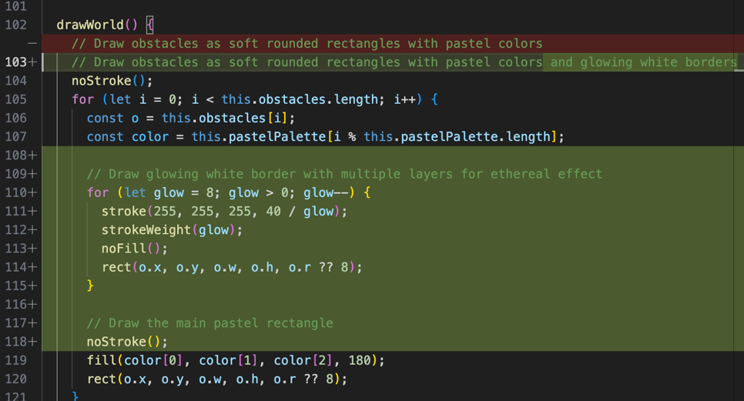
Rewrite this Player.js for a dreamscape p5.js experience. Instead of instant movement, give the player inertia — use this.vx and this.vy velocity variables. Each frame, add input direction to velocity scaled by an acceleration of 0.4, then multiply velocity by a friction of 0.88 so the player glides to a stop. Cap speed at this.s. Draw the player as a soft glowing white ellipse (radius ~10) with a larger translucent halo ellipse behind it (radius ~22, low opacity). No stroke | I'll open Player.js to inspect current code, then replace it with an inertia-based player.  I'll update Player.js to implement inertial movement and the soft glowing draw.  I'll apply the same patch again and include a short explanation.  Edited  Player.js+49-6  Updated Player.js — the player now uses inertia with vx/vy, acceleration 0.4, friction 0.88, speed capped at this.s. Drawing is a soft glowing white ellipse with a translucent halo.  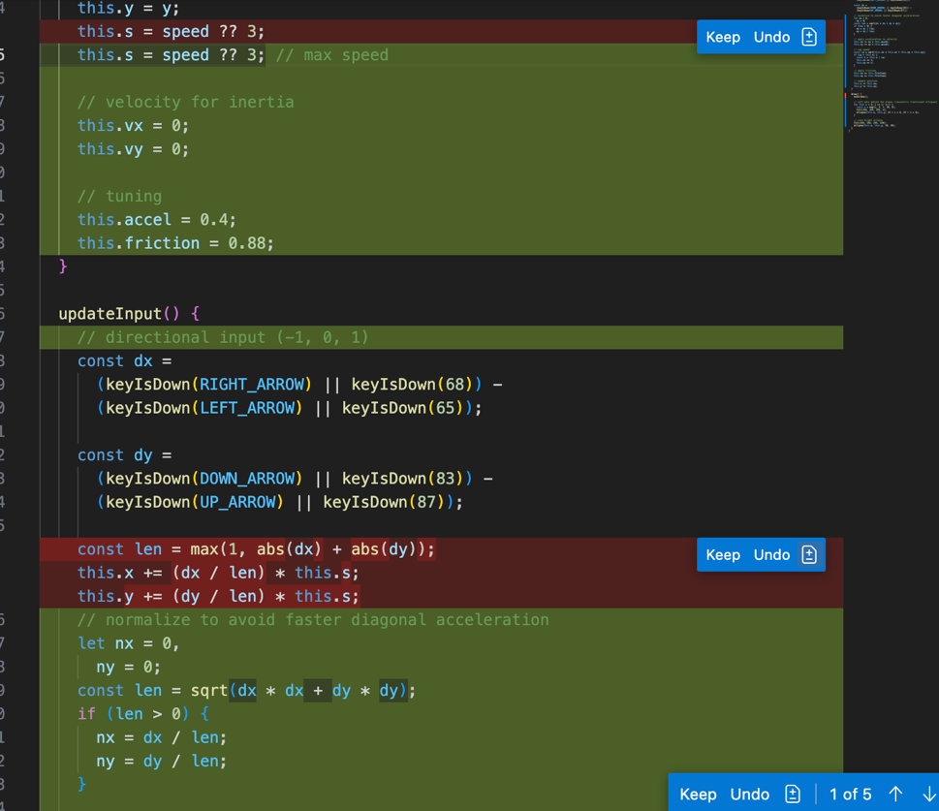
Rewrite this sketch.js to work with the updated WorldLevel, Player, and world.json for a dreamscape experience. Keep the same setup structure. Add these features: (1) Camera breathe — each frame offset the camera by sin(frameCount * breatheSpeed) * breatheAmount in both x and y, where those values come from level.breatheSpeed and level.breatheAmount. (2) After drawing the world and player (inside the push/pop), call level.drawMemories(player). (3) After the pop, draw a vignette overlay: a dark radial gradient rect covering the full canvas using drawingContext and a canvas radial gradient from transparent centre to rgba(10,5,20,0.7) at the edges. (4) Keep the R key reset. Remove the HUD coordinate debug line since the new HUD is poetic | I'll add a short plan and then update sketch.js to implement camera breathe, call drawMemories, add vignette, and keep/reset R key.  Now I'll update sketch.js to add camera breathing, call drawMemories inside the scene, and draw the vignette overlay. I'll replace the draw() function accordingly.  Edited  sketch.js+27-0  Starting: Run quick sanity checks (3/3)  Progress update: I updated sketch.js to add camera breathing, draw memories inside the scene, and render a radial vignette overlay. Next I'll run a quick read of the file to confirm the changes.  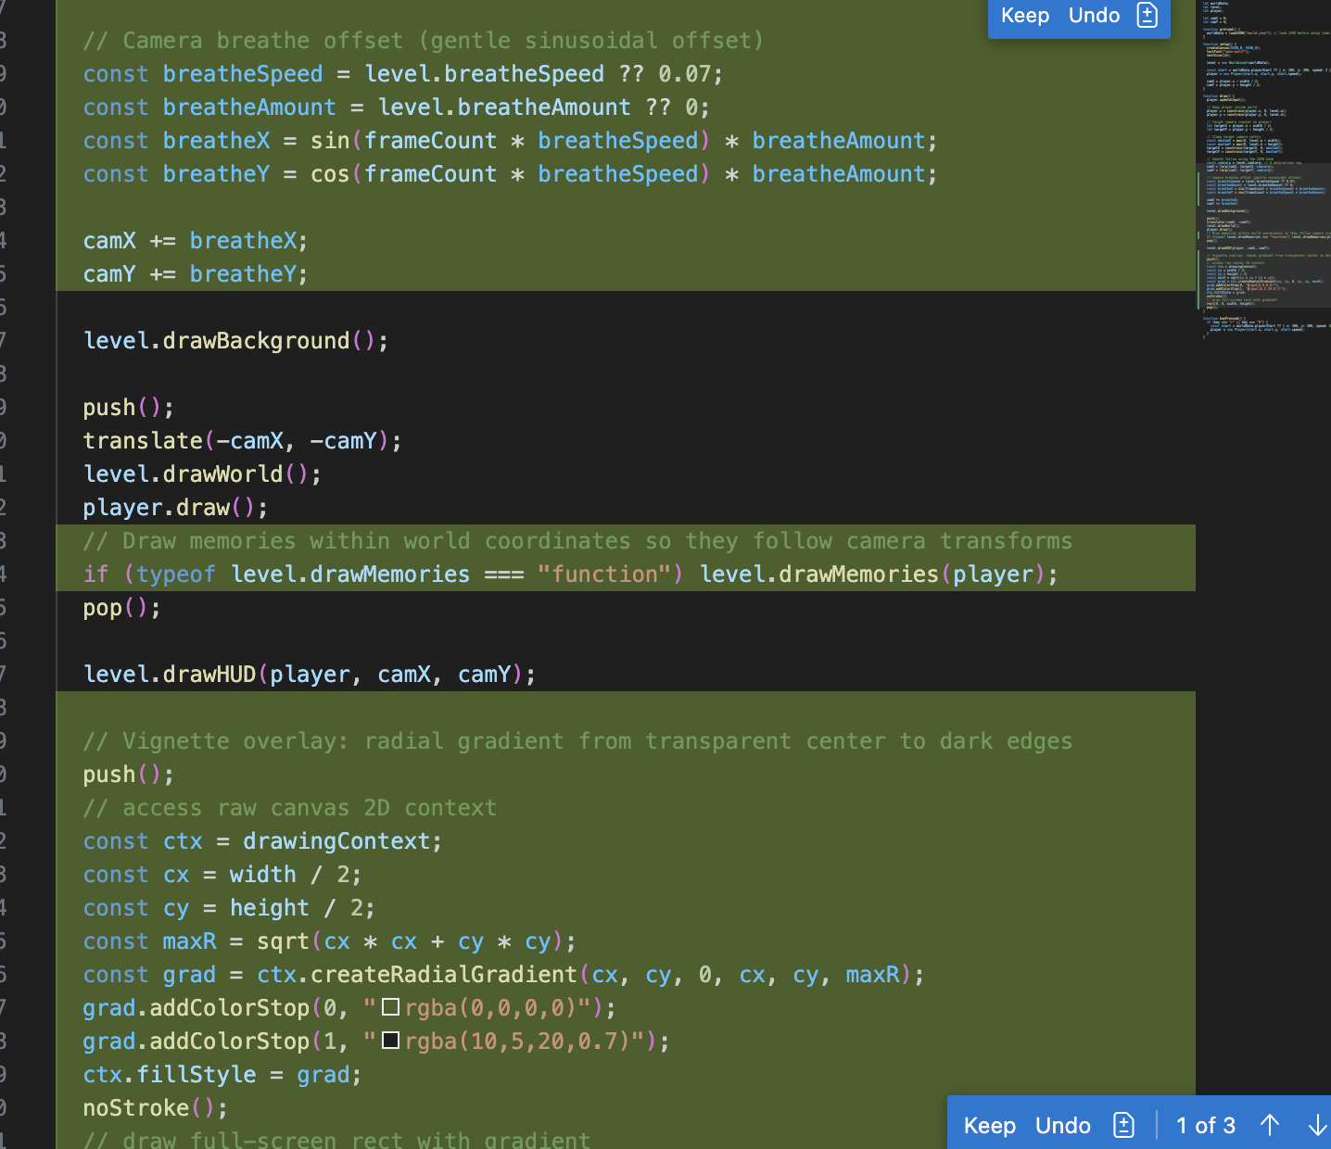
currently the camera is breathing too fast I want it to be more subtle and slower | I'll update sketch.js to scale down the effective breathe speed (and slightly damp the amount) so the camera breathes more slowly and subtly. I'll modify the breathe calculation.  Edited  sketch.js+7-4  Done — I scaled the camera breathe to be much slower and slightly more subtle by multiplying breatheSpeed by 0.02 and breatheAmount by 0.6. Reload the sketch; if you'd like it even slower/subtler, tell me a preferred multiplier or I can set explicit values.
make the rectangles into actual obstacles that "bounce" the player back if interacted with/touched | I'm going to add a handleCollisions(player) method to WorldLevel.js and call it from sketch.js after updating the player's position so obstacles will push and bounce the player.  Edited  WorldLevel.js+67-0  Edited  sketch.js+3-0  Done — obstacles now act as physical colliders: when the player touches a rectangle they are pushed out and their velocity reflects with a bounce. Test by running the sketch and moving into an obstacle; tell me if you'd like a firmer (less bouncy) or softer (more bouncy) response and I can adjust the restitution.  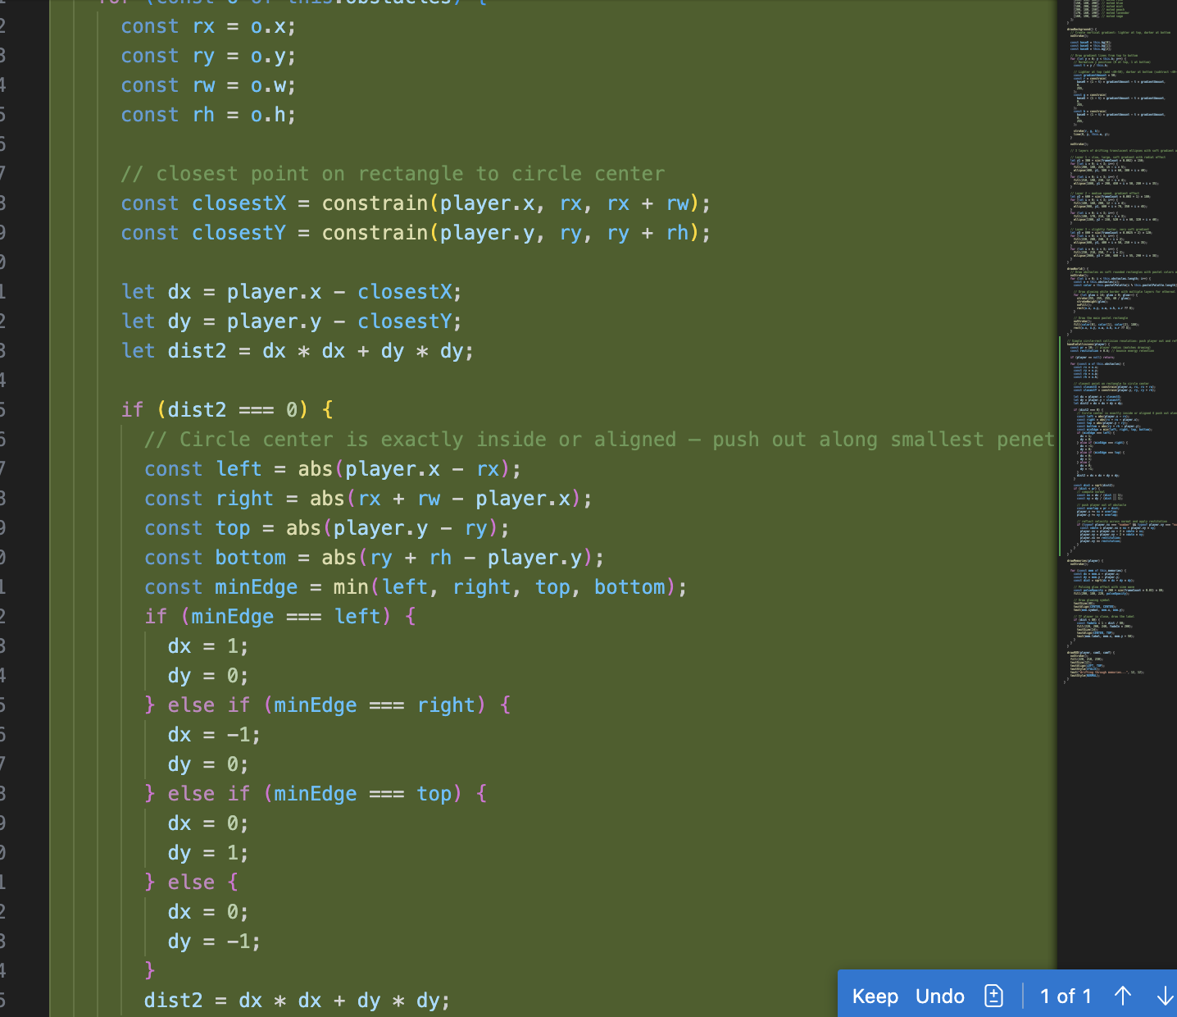
make the dynamix background a little more obvious, currently its not ovious enough there are things moving in the background | 